DBMS

PROJECT REPORT

Submitted By:

Inaamullah Sherwani (102318032)

Eesa Zargar (102318006)

Muteeb Mehraj (102318021)

Grocery Management System

Submitted To:

Dr. Rupali Bhardwaj

Grocery Management System

1. Introduction
In today’s digital era, efficient inventory and supply chain management is crucial for grocery stores. The Grocery Store Management System is a web-based application designed to assist store managers in tracking products, monitoring stock levels, checking expiry dates, and managing suppliers. This application centralizes essential grocery data to support day-to-day decision-making and inventory control.

2. Problem Statement
Managing a grocery store manually can be prone to errors and inefficiencies. Traditional systems often fail to:
- Track low-stock or out-of-stock items in real-time.
- Identify near-expiry or expired products promptly.
- Maintain supplier and supply records effectively.
- Provide summarized category-wise stock or supplier reports.
Such challenges can lead to wastage, customer dissatisfaction, and financial losses.

3. Objectives of the Project
The main objectives of this project are:
- To provide a centralized platform for managing grocery store inventory.
- To track products by category, stock quantity, and expiry date.
- To display low stock and expired or near-expiry items.
- To manage supplier information and supply quantities.
- To simplify CRUD operations (Create, Read, Update, Delete) on products.
- To generate meaningful summaries like stock by category and supply by supplier.

4. Methodology
This project is developed using MySQL database as the backend. The methodology includes:
- Database Design: Normalized tables (Product, Supplier, Supply) with appropriate foreign keys.
- Backend Development: Flask routes handle HTTP requests and execute SQL queries.
- Frontend Interface: HTML templates rendered using Jinja2 for dynamic content updates.
- Features Implemented:
  - View all products
  - View low stock / out of stock / near expiry / expired products
  - Add, update, and delete products
  - Stock summary by category
  - Supply summary by supplier (including contact info)

5. Software and Tools Used
Component | Tool/Technology
Programming Language | Python
Web Framework | Flask
Frontend | HTML, CSS, Jinja2
Database | MySQL
IDE | VS Code
Web Browser | Google Chrome
OS | Windows 11

6. Hardware Requirements
Component | Specification
Processor | AMD Ryzen 5
RAM | Minimum 4 GB
Storage | Minimum 500 MB free space
Display | Minimum 13” Monitor

Results
The system was successfully implemented and tested across various scenarios, ensuring its functionality and robustness.

Key Achievements:
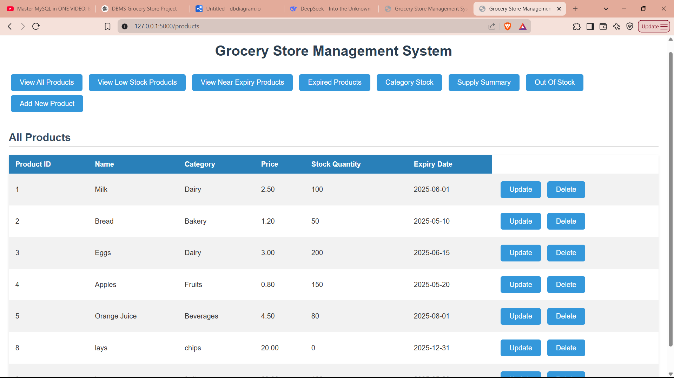
- Viewing all products and their detail:

- Update the product details:
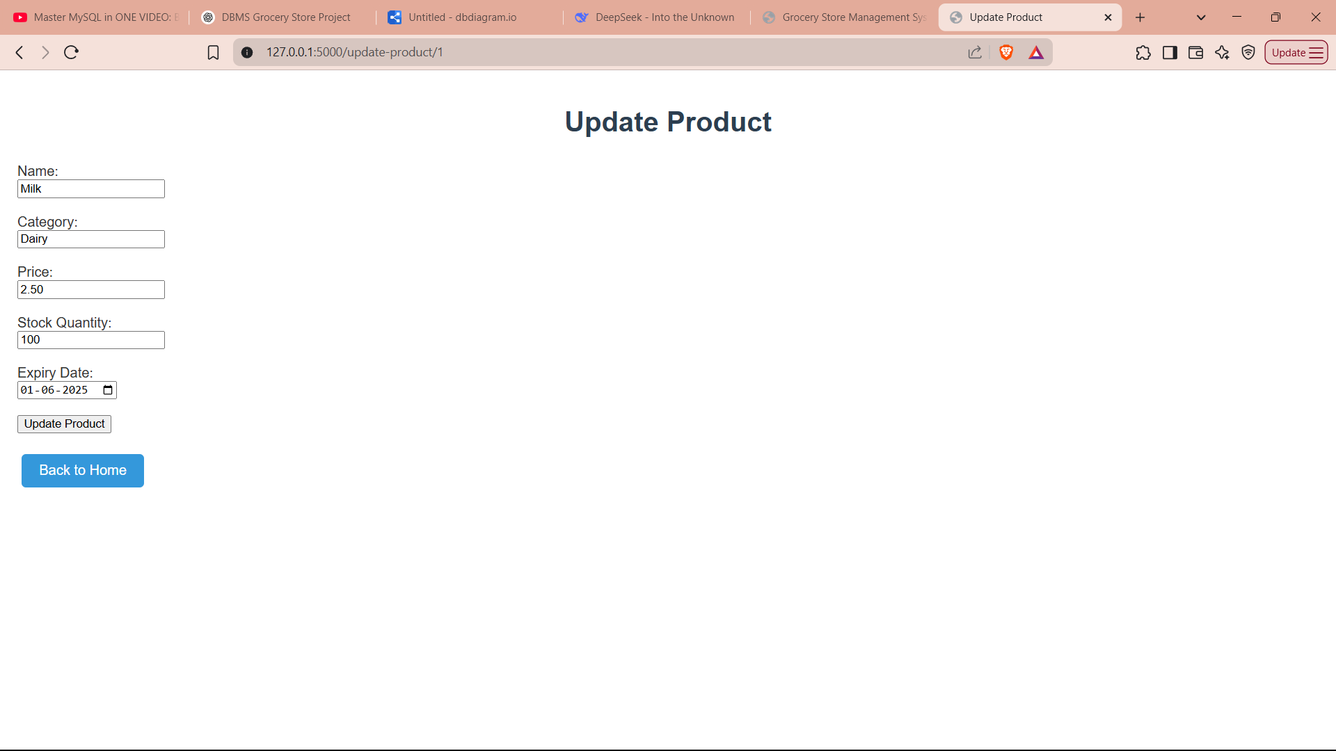
- View low stock products :
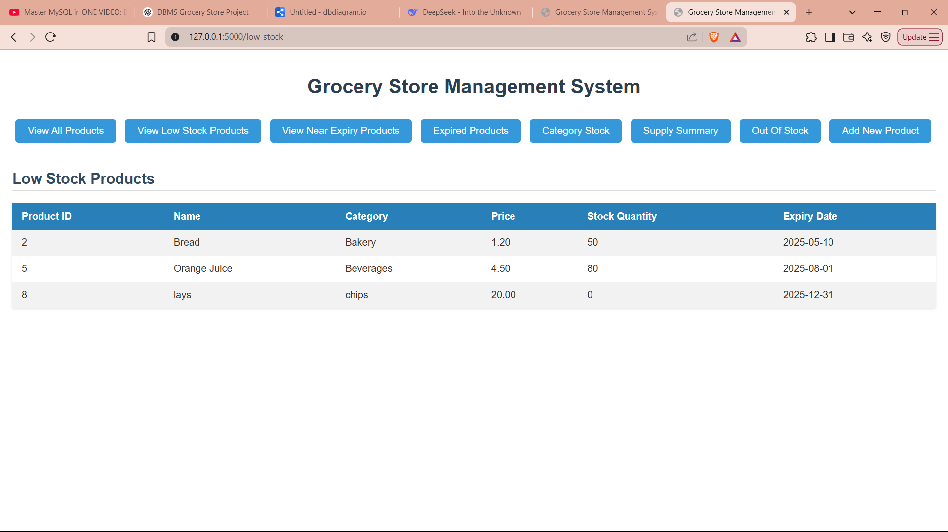

- View near expiry product:
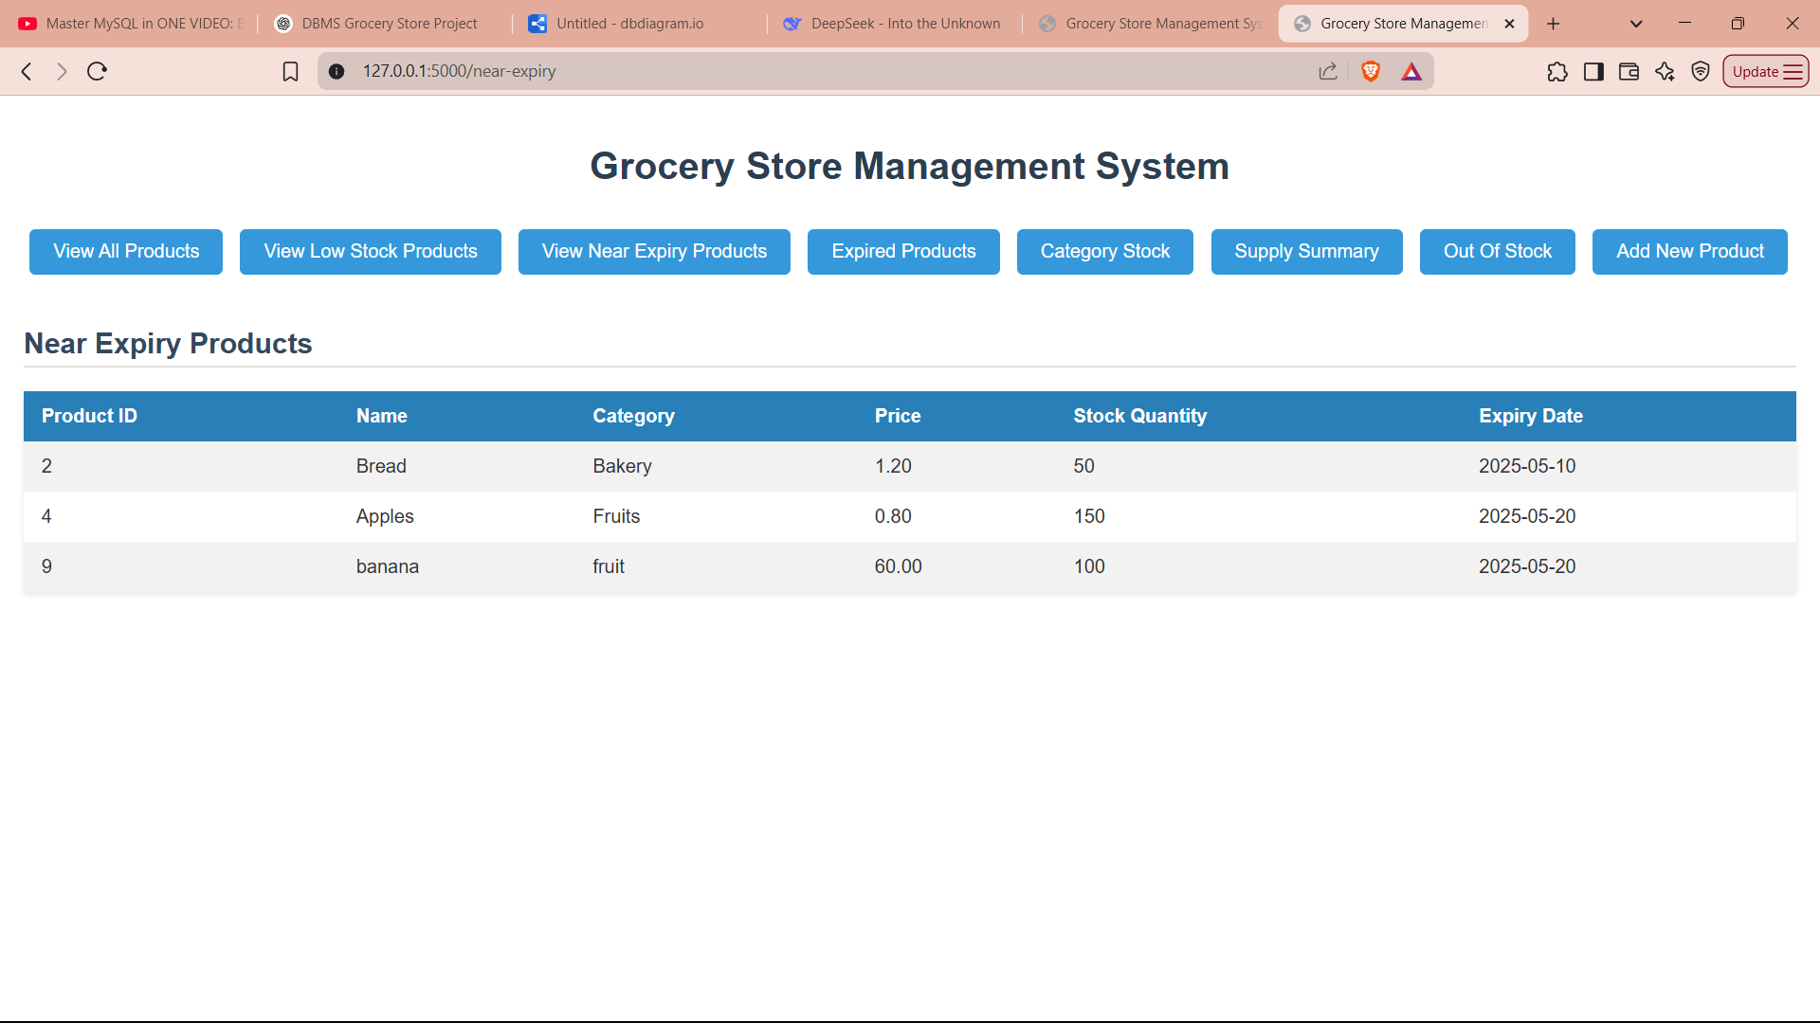

- View Expired product:
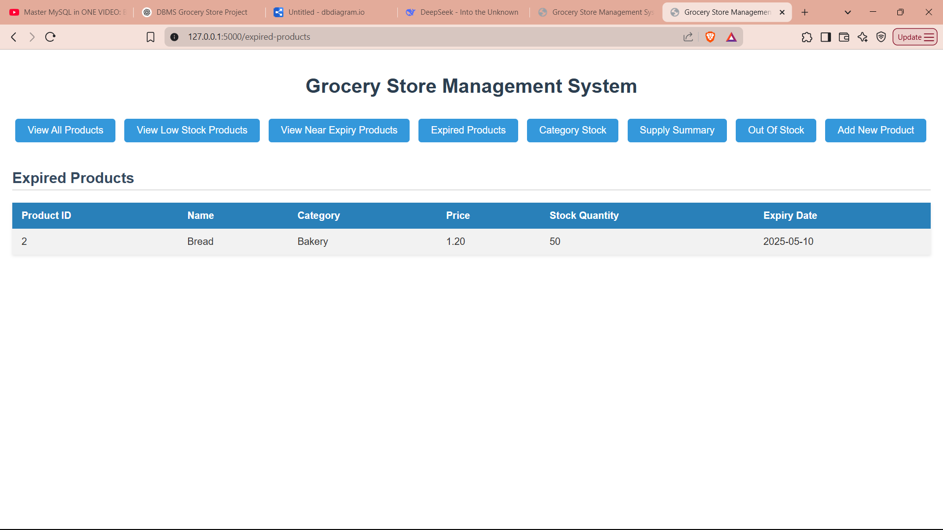

- View category wise stock :

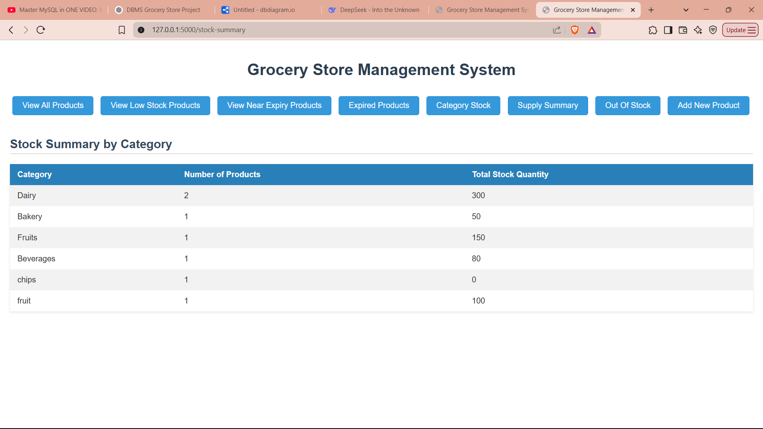
- View supply summary:
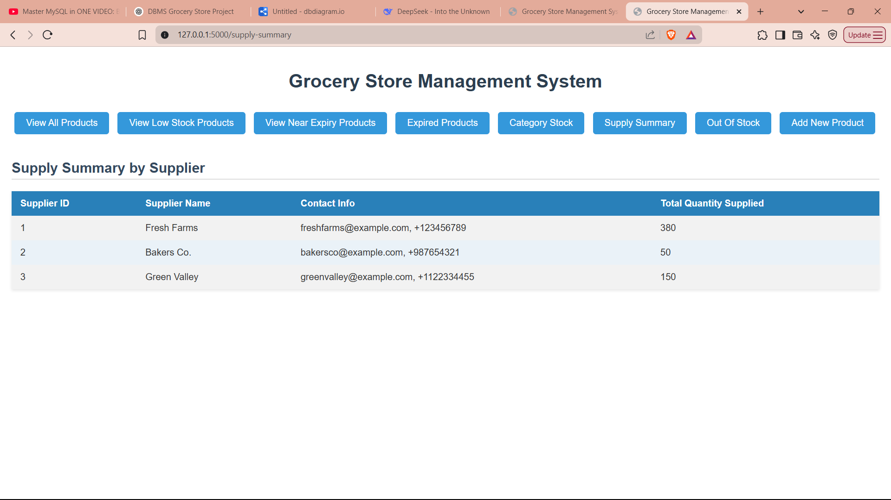

- View out of stock products:
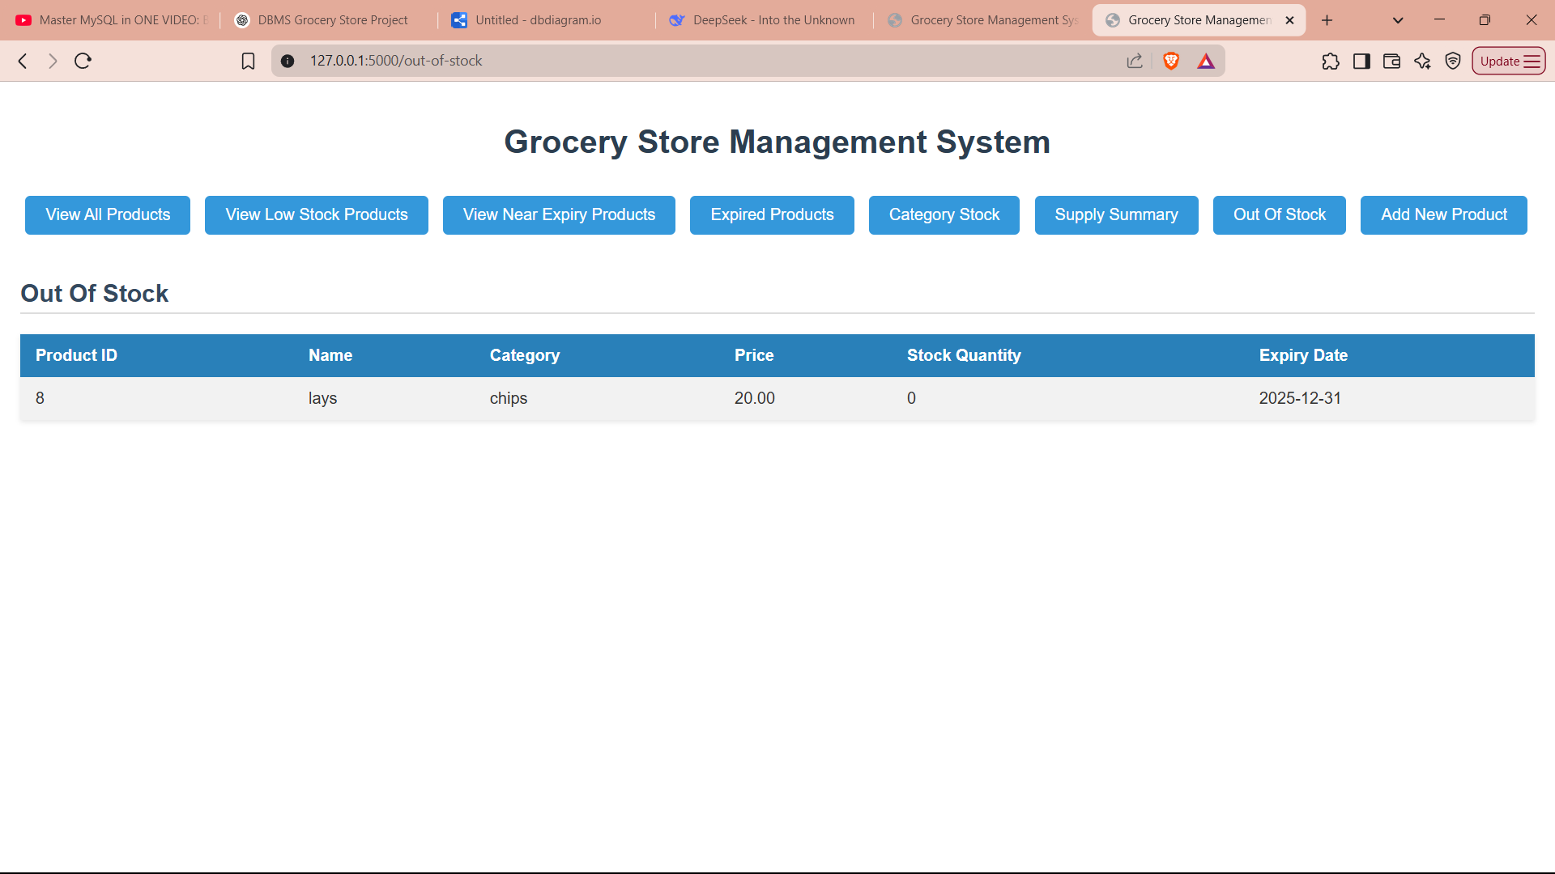

- Add a new product:

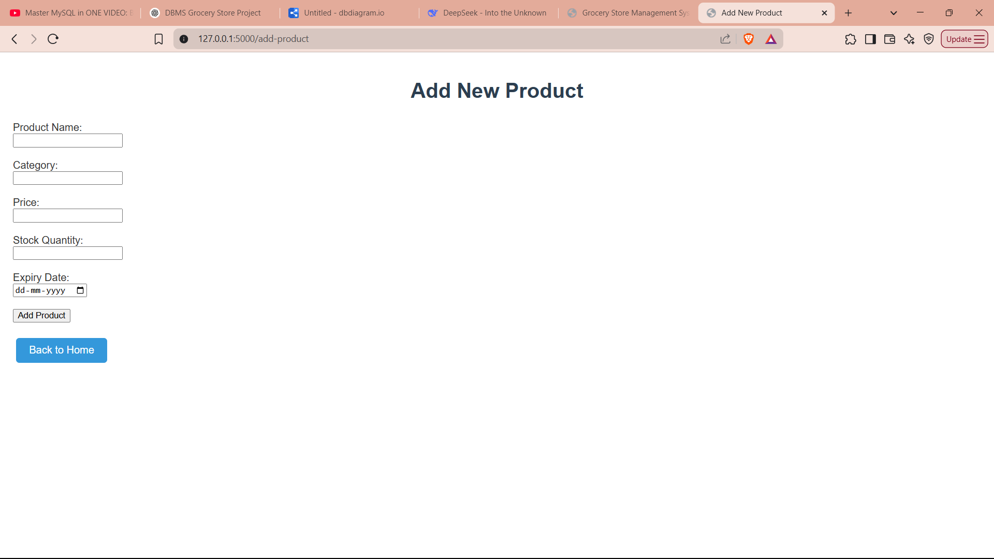

ER Diagram:

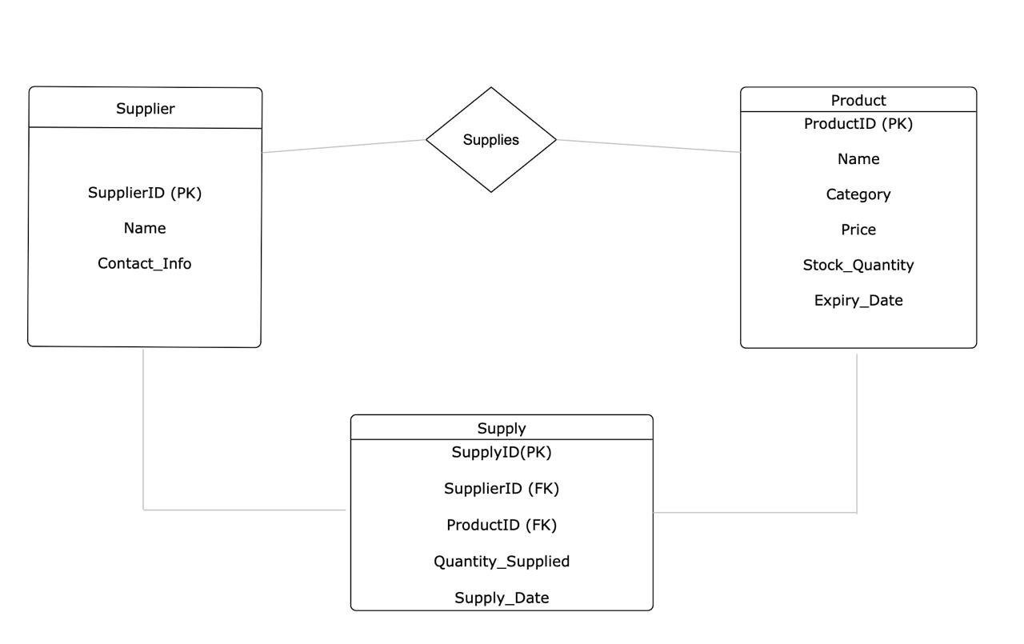

8. Conclusion
The Grocery Store Management System simplifies inventory management for store managers. It helps in tracking product stock, expiry dates, and supply details efficiently. The system provides an easy-to-use interface and reduces manual work, making store operations more organized and effective.

Future Scope
In the future, the system can be enhanced with features like user login, billing, sales tracking, and notifications for low stock or expiry. It can also be made accessible online and optimized for mobile use to support multiple branches or remote management.

